 | Suicide Prevention
 | 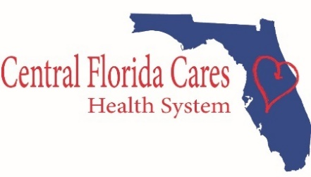 | Suicide is a major public health concern. Suicide is complicated and tragic, but it is often preventable. Knowing the warning signs for suicide, can help save lives.  In the United States, over 45,900 people died by suicide in 2020. Close to 800,000 people die by suicide every year. Furthermore, for each suicide, there are 27 suicide attempts. https://www.nimh.nih.gov/health/statistics/suicide.shtml#part_154968  In Florida, the total number of deaths by suicide in 2020 was 3,113. Suicide was the fourteenth leading cause of death. The crude suicide rate per 100,000 population was 14.4. This is a slight decrease from 2019 (16.1) (Florida Vital Statistics Annual Report 2020).  General Statistics  Suicide is the 12th leading cause of death in the US for all ages. (CDC)  There are nearly two times as many suicides (45,979) in the United States as there are homicides (24,576). (CDC)  Every day, approximately 125 Americans die by suicide. (CDC)  There is one death by suicide in the US every 11 minutes. (CDC)  Depression affects 20-25% of Americans ages 18+ in a given year. (CDC)  Suicide takes the lives of over 45,900 Americans every year. (CDC)  The highest suicide rates in the US are among American Indians, Alaskan Natives, and Non-Hispanic Whites. (CDC)  An estimated 66% U.S. adults ages 18 or older experiencing an episode of major depression receive treatment. (NIMH)  80%-90% of people that seek treatment for depression are treated successfully using therapy and/or medication. (TADS study)  An estimated quarter million people each year become suicide survivors. (AAS)  In 2020, 12.2 million adults seriously thought about suicide. (CDC)  People ages 85 and older have the highest rates of suicide. (CDC)
WARNING SIGNS

- Talking about wanting to die or
to kill oneself
- Looking for a way to kill oneself
- Talking about feeling hopeless or
having no purpose
- Talking about feeling trapped or
Being in unbearable pain
- Talking about being a burden to
others
- Increasing the use of alcohol or
drugs
- Acting anxious, agitated, or
reckless
- Sleeping too little or too much
- Withdrawing or feel isolated
- Showing rage or talk of
seeking revenge
- Displaying extreme mood swings

If you or someone you know is in crisis, call the Lifeline at 1-800-273-8255 OR Text SIGNS to 741741 for 24/7, anonymous, free crisis counseling.
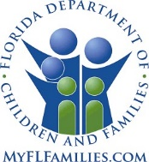
Links
https://www.nimh.nih.gov/health/topics/suicide-prevention/index.shtml
https://www.cdc.gov/suicide/suicide-data-statistics.html
https://suicidepreventionlifeline.org/
https://hopeforhealingfl.com/
https://www.take5tosavelives.org/knowhowtohelp

CFCHS is a managing entity contracted
with the Department of Children and Families.

