(TANFEZ1 Form – January 2025)  To determine eligibility, complete the information on the front and back as well as the attachment to this form: | Eligibility Form for TANF-Funded Services |  |  | 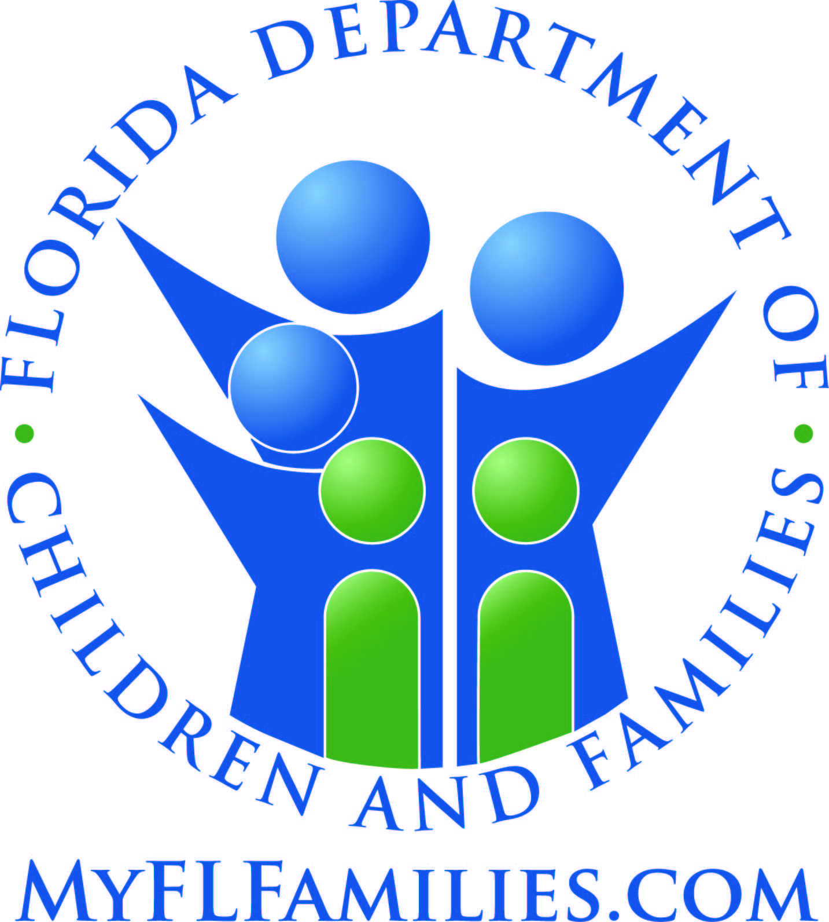
Section I: Identifying Information
Name: |  | Address: | City: |  | Zip:
Phone Number: |  | SSN: | Date of Birth:
Section II: Eligibility Information. Check the following if:
Step 1: □ The family receives temporary cash assistance, relative caregiver payments, food stamps, or the children in the family are eligible for Medicaid.
If the above is checked, the family is eligible for TANF-funded services. Go to Section III. If not checked, go to Step 2.
Step 2: The family receiving services includes one of the following:
□ A parent or relative caring for one or more children under 19 years of age;
□ A pregnant woman;
□ A non-custodial parent of a child under 19 years of age;
□ A family whose children have been removed from the home by the Child Welfare Program (where the service is included or added to the active family reunification goals
in the case plan);
□ A Supplemental Security Income (SSI) recipient or a Social Security Disability Insurance (SSDI) recipient.
Step 3: The TANF-funded services are for the benefit of a family member who is:
□ A citizen of the United States; or
□ A non-citizen who meets the TANF-eligible citizen criteria. (For determination, go to the attached sheet entitled "TANF- funded Services
non-citizen eligibility" and complete).
If EITHER of the above is checked, go to Step 4. If neither is checked, STOP. The family is NOT eligible for TANF-funded services. Go to
Section III.
Step 4: The services being provided are designed to:
□ 1. Provide services to needy families so that the child or children may be cared for in their own home or the home of relatives.
□ 2. Promote job preparation, work or marriage.
□ 3. Prevent or reduce the incidence of out-of-wedlock pregnancies.
□ 4. Encourage the formation and maintenance of two-parent families.
If number 3 or 4 above is checked, the family is eligible for TANF-funded services. Go to Section III.
If number 1 or 2 is checked, go to Step 5.
Step 5: □ The family income is less than 200% of the federal poverty level (See the income level chart on back and complete Financial Eligibility Section)
If Step 5 is checked, the family is eligible for TANF-funded services.

Section III: Eligibility Criteria
I certify that the information, provided on this form, is true and correct to the best of my knowledge. If the information changes, I will notify a program staff person of the new information.
__________________________________________________________________________ _____________________________________________________
Signature of Responsible Family Member Date signed
OFFICE USE ONLY:
Based on the information provided, the family is □ eligible OR □ not eligible for TANF-funded services for the period:
_______________________________________________________ through ____________________________________________________________________.

Name of program staff person (Please print): ________________________________________________________________________________________________
Signature: ____________________________________________________________________________ Date: __________________________________________

Worksheet on Family Income
Eligibility for TANF-Funded Services

200 Percent of the Federal Poverty Level
as of January 15, 2025
Family Size | Annual Income | Monthly Income
1 | $31,300 | $2,608
2 | $42,300 | $3,525
3 | $53,300 | $4,442
4 | $64,300 | $5,358
5 | $75,300 | $6,275
6 | $86,300 | $7,192
7 | $97,300 | $8,108
8 | $108,300 | $9,025

If Family Size is over 8, add $11,000 to annual income for each additional member.

Financial Eligibility (to be completed by program staff person):
1. Family size: ____________ | 2. The total family income is $ ___________ per ______________.
3. Convert to a monthly amount and list the family’s total monthly income: $ _____________
4. Is this amount less than 200% of the federal poverty level on the above chart? □ YES □ NO
If YES, the family is eligible for TANF-funded services. If NO, and the family has high expenses, consult with the
Department of Children and Families to explore potential financial eligibility.
Comments / Notes:_____________________________________________________________________________________
____________________________________________________________________________________________________
____________________________________________________________________________________________________
________________________________________________________________________________________________________________________________________________________________________________________________________
Name of program staff person (Please print): | Signature: ___________________________________________  Date: _______________________________________________
TANFEZwksht2

TANF-Funded Services for Non-Citizen Eligibility
(Attach to DCF Form TANF-E-Z-1)
Applicability and Scope: This form is to be used to determine eligibility for TANF-funded services for families who are non-citizens. In situations where some family members are citizens, some family members are non-citizens and the services are for the benefit of the family, the family would generally be eligible on this factor. If there is any discernable benefit to a family member who is a citizen, then the status of other members of the family does not need to be determined because the family is eligible due to the status of the citizen. The potential eligibility for non-citizens would be relevant when all of the family members are non-citizens, or when the services being provided are solely for the benefit of a family member who is not a citizen.
If some family members are eligible non-citizens, and some family members are ineligible non-citizens, then the family would generally be eligible, unless the service was provided solely for a member who is ineligible.
Note: Non-citizen Eligibility can be very complex. This form is intended to provide guidance that will cover many circumstances. If eligibility cannot be determined for an individual or family, consult with the applicable Department of Children and Families Program Office.
Eligibility for Services (section references are from the Immigration and Nationalities Act):
Step 1 – Are the relevant member(s) of the family a noncitizen who are now lawful permanent residents or who have or had a prior status below: (if so, check appropriate status)
□ Granted asylum under section 208  □ Refugees under section 207,  □ Amerasians | □ Individuals with deportation withheld by INS under section 243(h) or 241(b)(3),  - Cuban/Haitian Entrants (includes Cuban/ Haitian Parolees)  - Victims of Human Trafficking, their spouse or a minor dependent child (eligible from date of ORR certification)
If any of the above, the family is eligible for TANF-funded services. If not, go to Step 2.
Step 2 – Are the relevant member(s) lawful permanent residents, non-Cuban/Haitian parolees for a least one year under 212(d)(5) of the INA, or in a battered spouse status per USCIS for at least 5 years who are not listed in Step One AND who were in the U.S. prior to
August 22, 1996? □ YES □ NO
If YES, the family is eligible for TANF-funded services. If no, go to Step 3.
Sept 3 – Are the relevant member(s) lawful permanent residents, non Cuban/Haitian parolees for at least one year under 212(d)(5) of the INA, or in a battered spouse status per USCIS who are not listed in Step One AND who did not enter the U.S. until after
August 22, 1996? □ YES □ NO
If YES, the relevant member(s) are not eligible until 5 years, after the date of entry for LPR’s or 5 years from date of status for parolees and battered spouses. (Family members who are not in a status described in one of the steps above, are not likely to be eligible for TANF-funded services).
Eligibility Determination: The family is eligible based on the non-citizen status of relevant member(s): □ YES □ NO
Comments/ Notes: _________________________________________________________________________________
_______________________________________________________________________________________________

Name of program staff person (Please print): |  | Signature: _____________________________________  Date: _________________________________________
TANFEZA2UP3.Doc

